

**A MINI PROJECT REPORT ON**

**GUN OXIMETER**

SUBMITTED TO THE SAVITRIBAI PHULE PUNE UNIVERSITY, PUNE

IN THE PARTIAL FULFILLMENT OF THIRD YEAR OF ENGINEERING

**IN**

**ELECTRONICS AND TELECOMMUNICATION**

**BY**

|  |  |
| --- | --- |
| **VAISHNAVI V. DESHMUKH** | **PRN No. 72023821J** |
| **PRANAV R. ARJUN** | **PRN No. 72023742E** |

**UNDER THE GUIDANCE OF**

**Mrs. V.K Patil**

**ACADEMIC YEAR: 2022-23**

**CERTIFICATE**

This is to certify that Project Report entitled

**“*GUN OXIMETER*”**

Submitted by

***Ms. VAISHNAVI V. DESHMUKH* (*PRN No. 72023821J*)**

***Mr. PRANAV R. ARJUN******(PRN No.72023742E*** ***)***

is the record of bonafide work carried out by them in partial fulfillment of the requirement for the award of the Degree of **Bachelor of Engineering (Electronics and Telecommunication),** as prescribed by the Savitribai Phule Pune University in the Academic Year 2020-21.

This mini project report has not been earlier submitted to any other Institute or University for the award of any degree or diploma*.*

|  |  |  |
| --- | --- | --- |
| **Mrs. V.K Patil** | **Dr. M.P. Sardey** | **Dr. P.B. Mane** |
| Internal Guide | Head of Department | Principal |
| **Department of E&TC Engg.** | **Department of E&TC Engg.** | **AISSMS** |
|  |  | **Institute of Information Technology Pune.** |
|  |  |  |
| Date: | . |  |
|  |  |  |

**Acknowledgement**

It is my great pleasure in expressing sincere and deep gratitude towards my guide **Mrs V.K.Patil,** Electronics & Telecommunication Engineering Department for her valuable guidance and Project coordinator **Mrs. D.M. Yewle** for his constant support throughout this work and help to peruse additional studies in studies in Internet Of Things.

We take this opportunity to thank Head of the Department **Dr.M.P. Sardey** and all staff members of department of Electronics &Telecommunication Engineering AISSMS IOIT, Pune, for cooperation provided by them in many ways.

The motivation factor for this work was the inspiration given by our honorable principal **Dr. P.B. Mane.**

Lastly, I am thankful to those who have directly or indirectly supported for our work.

Sign Sign

***Ms. VAISHNAVI V. DESHMUKH Mr. PRANAV ARJUN***

|  |  |  |
| --- | --- | --- |
| **Sr No.** | **TITLE** | **PAGE NO.** |
| **1** | **Abstract** | **5** |
| **2** | **Introduction** | **6** |
| **3** | **Literature review** | **7** |
|  | Review of patents |  |
| **4** | **Aim and Objective** | **8** |
|  | Problem statement |  |
|  | Objectives |  |
|  | Methodology |  |
| **5** | **Block diagram of the system and its explanation** | **9** |
| **6** | **Hardware design** | **10** |
|  | Construction and circuit diagram |  |
| **7** | **Software design** | **14** |
|  | Diagrams |  |
| **8** | **Result and analysis** | **19** |
| **9** | **Challenges and Conclusion** | **20** |
| **10** | **Appendix** | **21** |
|  | Datasheets |  |

**INDEX**

**ABSTRACT**

Gun oximeter is a IOT based project which can we very useful in pandemic and post pandemic period. The COVID-19 virus has changed the lifestyle of people in every way. But coping with this virus we have to take precautions.

High temperature and Low oxygen which are the most primary signs needs to checked frequently at public places. For this Gun Oximeter which is a combination of Temperature Gun and Oximeter , will be very useful.

Gun Oximeter contains two main sensors , IR temperature sensor and Spo2 sensor which helps us detect two parameters using single device.

More over we have integrated this hardware with a Web Application. Web Application totally changes the picture of traditional measuring systems. The sensor data which is collected at public places is displayed on a web page . Here one can store the data along with the person’s information.

The sensor data + person’s information is stored in an organized way so that this data can be further used for any type of analysis.

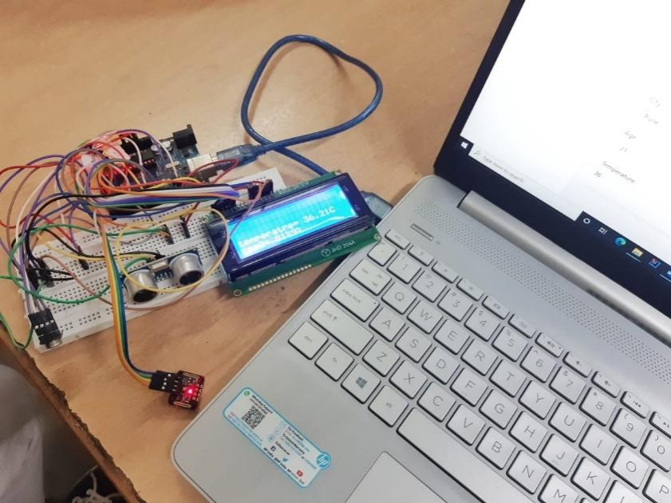

**Fig.1** Gun Oximeter Circuit

**INTRODUCTION**

Deadly corona virus changed our lifestyle in every way. We are stuck in our houses. Once we step out for work we are in constant danger of getting infected. But we have to find a feasible way to live with this new lifestyle. While adjusting to the rush one must take into account that Corona Virus is not yet over.

And neither it will be totally eradicated. Government are making several attempts to make sure every person is aware of the basic things which can help us protect from getting affected.

High Temperature and Low Oxygen level are primary signs of infected person.

Often times people are not aware that they are infected unless their O2 levels are checked.

At the public places only temperature is checked. Oxygen level is totally neglected. Oxygen level is more important as it tells the severity of the infection. There are the cases where due to normal temperature but very low oxygen level, people are getting into serious conditions.

There are several places where currently measuring oxygen saturation level is ignored. This is due to several problems

1. Problem of handling two instruments at same time.
2. Cost of the two devices is more.
3. There is also carelessness among the people.
4. Unawareness among the people.

However even though if the temperature is measured , no proper record is kept. A hard copy is used by the security guards , which is not a proper way of storing the data. There is actually no use of measuring the temperature as the data is neglected.

This data is very useful while making the data analysis of covid patients. One can use this data to check which area is in red zone , which age group is most affected etc.

Gun Oximeter is a device where one can measure both temperature and oxygen at public place . Not only this we can store this sensor data in organized way in a database along with the person’s information which can be retrieved easily.

**LITERATURE REVIEW**

1. **Quast, Kimberger, The Significance of Core Temperature— Pathophysiology and Measurement Methods; Dräger Medical GmbH: Lübeck, Germany, 2014.**

Infrared thermometry is a mature but dynamic technology that has gained the respect of many industries and institutions. It is an indispensable technique for many temperature measurement applications, and the preferred method for some others.

1. **Hsuan-Yu Chen, Andrew Chen, Chiachung Chen, Investigation of the Impact of Infrared Sensors on Core Body Temperature Monitoring by Comparing Measurement Sites, MDPI, Basel, Switzerland, May 2020**

The important formulas are as follows: Kirchoff's Law When an object is at thermal equilibrium, the amount of absorption will equal the amount of emission.

Infrared Temperature Measurement The modern IRT is founded on this concept, but is more technologically sophisticated to widen the scope of its application.

1. **Wukitsch MW, Petterson MT, Tobler DR, Pologe JA. Pulse oximetry: analysis of theory, technology, and practice. J Clin Monit.**

The oximetric measurement of oxygen concentration in blood has been a valuable tool since it became commercially available in the United States in the early 1970's. Generally, an oximeter is a photoelectric instrument that continually measures the oxygen content of blood or oxygen saturation in a person by measuring the intensity of a light beam transmitted through body tissue. Oxygen saturation is numerically displayed as a percentage, and is typically accompanied by an audible alarm if the current value is outside present limits of acceptable saturation. Motion artifact continues to be a significant source of error and false alarms

1. US6129673A - Infrared thermometer - Google Patents

To overcome the limitations of the prior art, the invention provides a method and system for performing non-contact temperature measurement of an object accurately and efficiently.

In addition to the ambient T a , the first thermistor 19 is positioned within the chamber to be exposed to the waveguide 15 and, consequently, to IR radiation entering the probe 4 through the window 17.

1. DE19526556A1 - Infrared temperature sensor - Google Patents

Infrared temperature sensors advantageously do not require any Surface contact, but instead use an infrared detector, the infrared light gets from the place where a temperature measurement should be done. Appropriate electronics with the infrared sensor is connected, determines the temperature at the desired location.

1. US4883353A - Pulse oximeter - Google Patents

BACKGROUND OF THE INVENTION This invention relates to displaying the process used by a pulse oximeter for identifying the maximum and minimum values of pulsatile waveforms in order to determine the amplitudes used for calculating oxygen

**AIM AND OBJECTIVE**

**Problem Statement:** To design a single device which can measure the temperature and oxygen of people in public places. Storing this data in organized way on database for further analysis.

**Aim**

The motive of Gun Oximeter is to make the process of measuring temperature and oxygen of people at public places much easier , faster and safer. Along with this storing the data collected from public places in such organized way so that it can be used for data analysis in future.

**Objectives:-**

1. To design two in one device for accurate measurement of temperature and oxygen .
2. To interface the various sensors for detection with the microcontroller.
3. To collect the sensor data (temperature, oxygen saturation readings.) in proper format.
4. To build a Web Application where the sensor data will be stored along with person’s information.
5. To migrating this data in Database where it can be stored properly.
6. To interface hardware with software webapp, collecting the sensor readings and storing it for further analysis.

**METHODOLOGY**

1. The project is divided into two parts. Hardware and Software.
2. Gun Oximeter works on two main sensors. IR Temperature detection sensor (MLX90614) and SPO2 Oxygen saturation sensor (MAX30102).
3. Both the sensors are interfaced with the Arduino Board . Measurements of the person ; temperature and oxygen readings are taken on the Arduino IDE.
4. The temperature and Spo2 reading are collected from the sensors and are then sent to the Python terminal.
5. Here the interfacing of Arduino with Python is done. The readings taken from sensors are displayed on the python terminal.

**SPECIFICATION OF THE SYSTEM: -**

1. **Temperature sensor (MLX90614):**

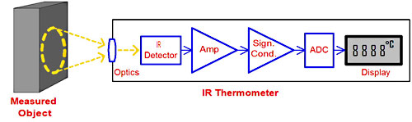

**Fig 2** Temperature sensor principle

Infrared thermometers employ a lens to focus the infrared light emitting from the object onto a detector known as a thermopile.  
The thermopile is nothing but thermocouples connected in series or parallel. When the infrared radiation falls on the thermopile surface, it gets absorbed and converts into heat. Voltage output is produced in proportion to the incident infrared energy. The detector uses this output to determine the temperature, which gets displayed on the screen.

1. 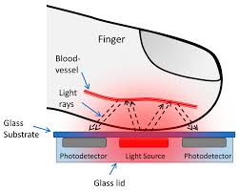**Spo2 sensor (MAX30102):**

**Fig 3** Oximeter Principle

Pulse oximetry is simple to carry out; it only uses two different light sources and a [photodiode](https://www.sciencedirect.com/topics/engineering/photodiode) . Depending on the measurement site, either the transmissive or the reflective mode can be used same side, and light is reflected to the photodiode across the measurement site.

**Detailed Specifications:**

1. Operating Voltage= 5V
2. Operating temperature = Room temperature.
3. Spo2 sensor **MAX30102** =
   1. Power supply 3.3V to 5.5V
   2. Current draw ~600μA (during measurements)

~0.7μA (during standby mode)

* 1. IR LED Wavelength 880nm

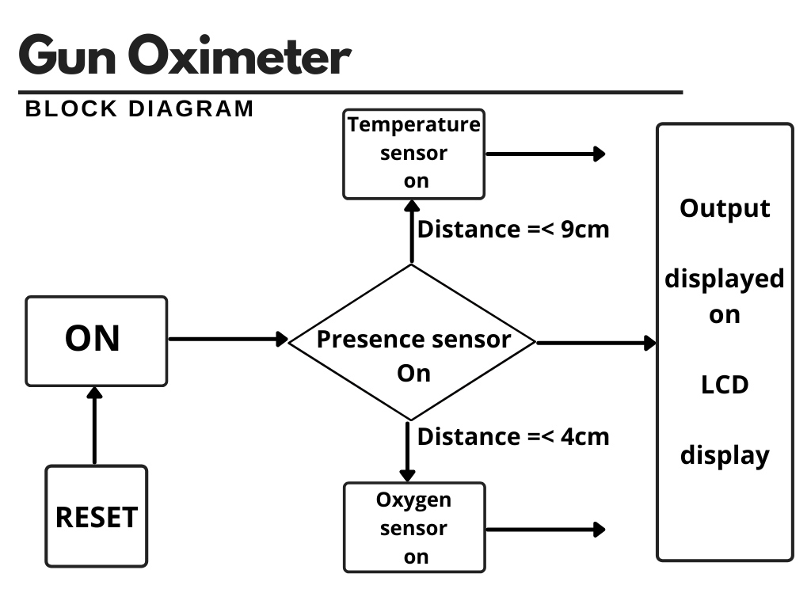

**Fig 4** BLOCK DIAGRAM OF THE SYSTEM

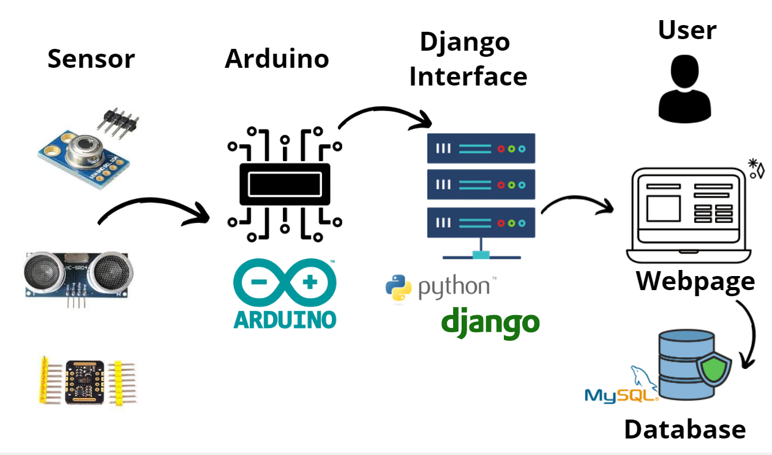

**Fig 5** Data Flow Diagram

**Hardware Design**

In this project we have used following hardware components:

1. Arduino UNO R3 board.
2. Temperature Sensor (MLX90614)
3. SPO2 Sensor (Max30102)
4. 20x4 LCD Display
5. Breadboard
6. Jumper Wires.

**1.Arduino Uno R3**:-

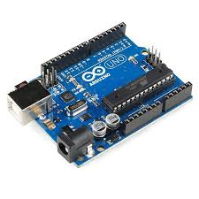The Arduino Uno R3 is a microcontroller board based on a removable, dual inline-package (DIP) ATmega328 AVR microcontroller. It has 20 digital input/output pins (of which 6 can be used as PWM outputs and 6 can be used as analog inputs). Programs can be loaded on to it

**Fig 6** Arduino UNO R3

from the easy-to-use Arduino computer program. The Arduino has an extensive support community, which makes it a very easy way to get started working with embedded electronics. The R3 is the third, and latest, revision of the Arduino Uno.

* Serial Pins 0 (Rx) and 1 (Tx):
* External Interrupt Pins 2 and 3:
* PWM Pins 3, 5, 6, 9 and 11:
* SPI Pins 10 (SS), 11 (MOSI), 12 (MISO) and 13 (SCK):
* In-built LED Pin 13
* AREF:
* Reset pin.

**2.Temperature Sensor (MLX90614)**:-

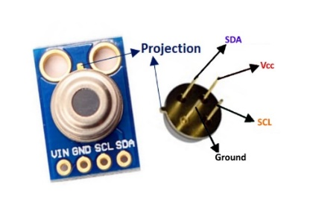The MLX90614 is a **Contactless Infrared (IR) Digital Temperature Sensor**that can be used to measure the temperature of a particular object ranging from -70° C to 382.2°C. The sensor uses IR rays to measure the temperature of the object without any physical contact and communicates to the microcontroller using the I2C protocol.

**MLX90614 Temperature Sensor Specifications**

* Operating Voltage: 3.6V to 5V (available in 3V and 5V version)
* Supply Current: 1.5mA
* Object Temperature Range: -70° C to 382.2°C
* Ambient Temperature Range: -40° C to 125°C

**3.Oxygen Saturation Detection Sensor (MAX30102)**:-

The MAX30102 is an integrated pulse oximetry and heart-rate monitor module. It includes internal LEDs, photodetectors, optical elements, and low-noise electronics with ambient light rejection.

1. **Technical Specifications**

|  |  |
| --- | --- |
| Power supply | 3.3V to 5.5V |
| Current draw | ~600μA (during measurements) |
| ~0.7μA (during standby mode) |
| Red LED Wavelength | 660nm |
| IR LED Wavelength | 880nm |
| Temperature Range | -40˚C to +85˚C |
| Temperature Accuracy | ±1˚C |

**4.Liquid Crystal Display (20x4)**:-

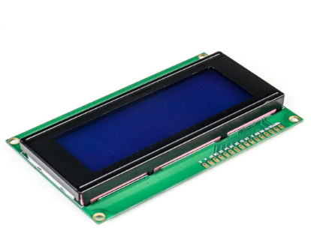A 20x4 LCD display is very basic module and is very commonly used in various devices and circuits. These modules are preferred over seven segments and other multi segment LEDs. The reasons being: LCDs are economical; easily programmable; have no limitation of displaying special & even custom characters (unlike in seven segments), animations and so on.

**WORKING OF GUN OXIMETER.**

* In the Gun oximeter, Ultrasonic sensor detects the Human Presence. Once a Object is detected at certain distance Gun Oximeter is switched on.
* After switching on , when object is at particular distance, temperature sensor gets activated and temperature is displayed on LCD display.
* Then after temperature , person is asked to get more closer to the gun oximeter for SPo2 detection. After standing at particular distance , SPO2 sensor gets activated and spo2 level is displayed.
* The distances for which the sensors should switched on and off can be decided by user.after the data is being captured it is then sent to the python server.
* The Python server will then send the data to the Django Web page .
* Once the temperature and spo2 readings are displayed on the webpage the user can then enter the person’s information.
* After the form is filled it is submitted . This data is saved in the MySQL database.
* 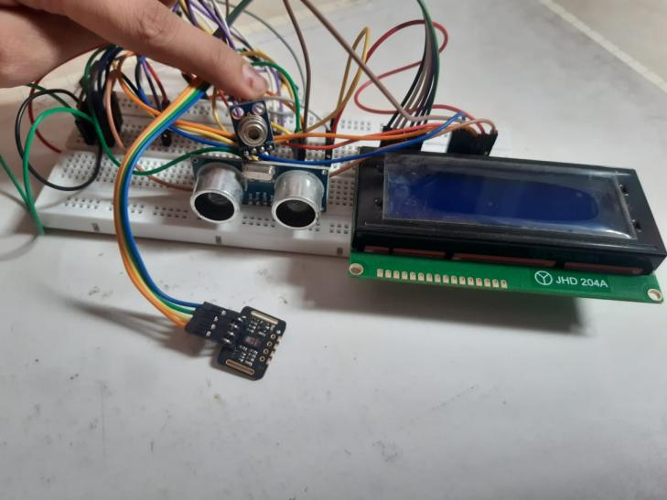This data can be used for future uses.

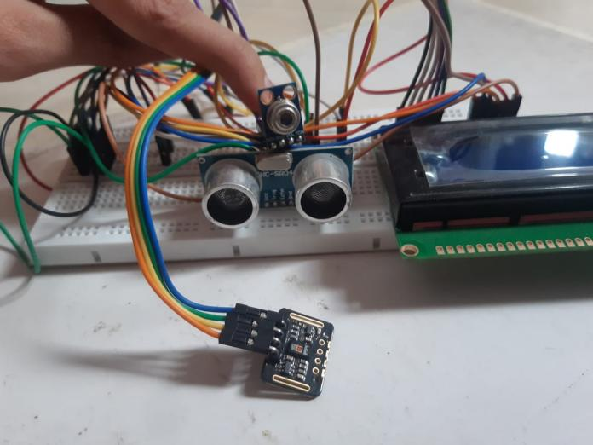

**Fig 10** Hardware Circuit

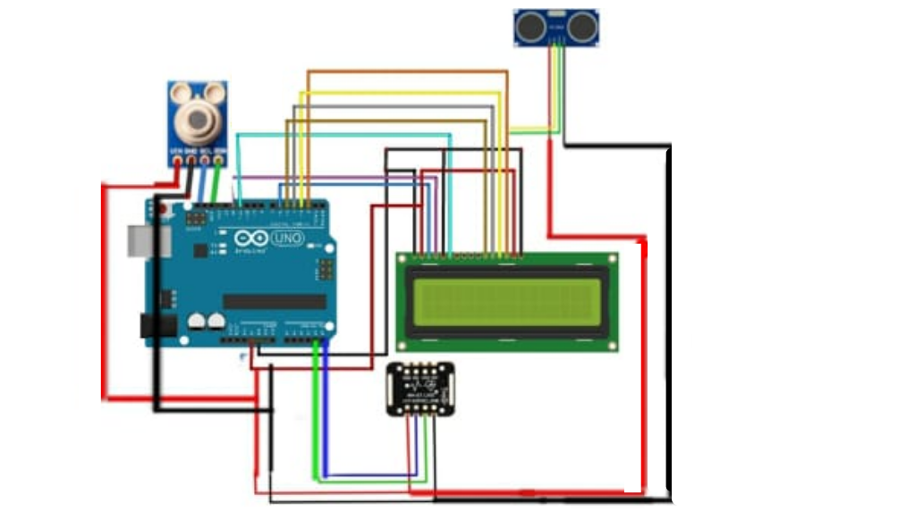

Circuit Diagram

**Software design**

We have used Django framework for building the website which can display and store the data

What is the Django Framework?

Django is an open-source python web framework used for rapid development, pragmatic, maintainable, clean design, and secure websites. A web application framework is a toolkit of all components needed for application development.

The main goal of the Django framework is to allow developers to focus on components of the application that are new instead of spending time on already developed components. Django is fully featured than many other frameworks on the market. It takes care of a lot of hassles involved in web development; enables users to focus on developing components needed for their application.

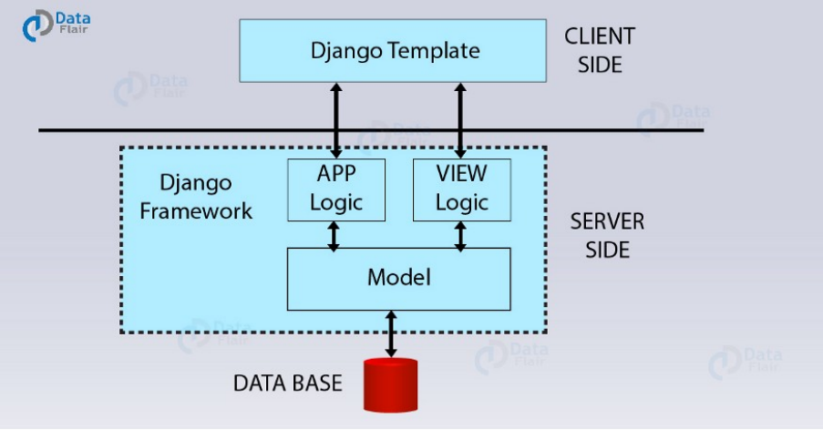

**Fig 12** Django Work Flow

**Code**

**1. Arduino Code :**

//GUN OXIMETER.

// Adding libraries

#include <Wire.h>

#include "MAX30105.h"

#include "spo2_algorithm.h"

#include <Adafruit_MLX90614.h>

#include <LiquidCrystal.h>

int Contrast=145;

LiquidCrystal lcd(12, 11, 5, 4, 3, 2);

int temp;

#include<NewPing.h>

const int trigPin = 9;

const int echoPin = 10;

float duration, distance;

Adafruit_MLX90614 mlx = Adafruit_MLX90614();

MAX30105 particleSensor;

#define MAX_BRIGHTNESS 255

#if defined(__AVR_ATmega328P__) || defined(__AVR_ATmega168__)

//Arduino Uno doesn't have enough SRAM to store 100 samples of IR led data and red led data in 32-bit format

//To solve this problem, 16-bit MSB of the sampled data will be truncated. Samples become 16-bit data.

uint16_t irBuffer[50]; //infrared LED sensor data

uint16_t redBuffer[50]; //red LED sensor data

#else

uint32_t irBuffer[50]; //infrared LED sensor data

uint32_t redBuffer[50]; //red LED sensor data

#endif

int32_t bufferLength; //data length

int32_t spo2; //SPO2 value

int8_t validSPO2; //indicator to show if the SPO2 calculation is valid

int32_t heartRate; //heart rate value

int8_t validHeartRate; //indicator to show if the heart rate calculation is valid

byte pulseLED = 11; //Must be on PWM pin

byte readLED = 13; //Blinks with each data read

void setup() {

//LCD Set UP

analogWrite(6,Contrast);

lcd.begin(20, 4);

//Presence Sensor Setup

pinMode(trigPin, OUTPUT);

pinMode(echoPin, INPUT);

Serial.begin(9600);

// //HR and SPO2 Sensor Setup

Serial.begin(9600); // initialize serial communication at 115200 bits per second:

pinMode(pulseLED, OUTPUT);

pinMode(readLED, OUTPUT);

if (!particleSensor.begin(Wire, I2C_SPEED_FAST)) //Use default I2C port, 400kHz speed

{

Serial.println(F("MAX30105 was not found. Please check wiring/power."));

while (1);

}

Serial.read();

byte ledBrightness = 60; //Options: 0=Off to 255=50mA

byte sampleAverage = 4; //Options: 1, 2, 4, 8, 16, 32

byte ledMode = 2; //Options: 1 = Red only, 2 = Red + IR, 3 = Red + IR + Green

byte sampleRate = 100; //Options: 50, 100, 200, 400, 800, 1000, 1600, 3200

int pulseWidth = 411; //Options: 69, 118, 215, 411

int adcRange = 4096; //Options: 2048, 4096, 8192, 16384

particleSensor.setup(ledBrightness, sampleAverage, ledMode, sampleRate, pulseWidth, adcRange);

//Configure sensor with these settings

mlx.begin();

}

void loop() {

digitalWrite(trigPin, LOW);

delayMicroseconds(1000);

digitalWrite(trigPin, HIGH);

delayMicroseconds(1000);

digitalWrite(trigPin, LOW);

duration = pulseIn(echoPin, HIGH);

distance = (duration*.0343)/2;

lcd.clear();

lcd.setCursor(0, 0);

lcd.print(distance);

lcd.print(",");

// Temperature

temp= mlx.readObjectTempC();

//LCD

delay(500);

lcd.clear();

lcd.setCursor(0, 2);

lcd.print("temperatre= ");

lcd.print(mlx.readObjectTempC());

lcd.print("C");

delay(1000);

//SPO2

long irValue = particleSensor.getIR();

bufferLength = 50; //buffer length of 100 stores 4 seconds of samples running at 25sps

//read the first 50 samples, and determine the signal range

for (byte i = 0 ; i < bufferLength ; i++)

{

while (particleSensor.available() == false) //do we have new data?

particleSensor.check(); //Check the sensor for new data

redBuffer[i] = particleSensor.getRed();

irBuffer[i] = particleSensor.getIR();

particleSensor.nextSample();

}

maxim_heart_rate_and_oxygen_saturation(irBuffer, bufferLength, redBuffer, &spo2, &validSPO2, &heartRate, &validHeartRate);

//Continuously taking samples from MAX30102. Heart rate and SpO2 are calculated every 1 second

while (1)

{

//dumping the first 25 sets of samples in the memory and shift the last 75 sets of samples to the top

for (byte i = 15; i < 50; i++)

{

redBuffer[i - 15] = redBuffer[i];

irBuffer[i - 15] = irBuffer[i];

}

//take 25 sets of samples before calculating the heart rate.

for (byte i = 25; i < 50; i++)

{

while (particleSensor.available() == false) //do we have new data?

particleSensor.check(); //Check the sensor for new data

digitalWrite(readLED, !digitalRead(readLED)); //Blink onboard LED with every data read

redBuffer[i] = particleSensor.getRed();

irBuffer[i] = particleSensor.getIR();

particleSensor.nextSample();

if (validSPO2){

Serial.print(distance);

Serial.print(",");

Serial.print(temp);

Serial.print(",");

Serial.print(spo2, DEC);

Serial.println(",");

}

delay(1000);

//LCD

lcd.setCursor(0, 3);

lcd.print("spo2= ");

lcd.print(spo2);

lcd.print("%");

}

maxim_heart_rate_and_oxygen_saturation(irBuffer, bufferLength, redBuffer, &spo2, &validSPO2, &heartRate, &validHeartRate);

}

}

}

**Python Code**

import serial

import time

import schedule

from django.http import JsonResponse

import numpy as np

def Arduino(request):

arduino = serial.Serial('com3', 9600)

print('Established serial connection to Arduino')

data = arduino.readline()

data = str(data,'utf')

data=data.strip('\r\n')

data=data.split(",")

# Decalring the varibales

dist=(data[0])

temp = (data[1])

spo2 = (data[2])

arduino.close()

return JsonResponse({'temp': temp, 'spo2': spo2})

**Test Results and Analysis**

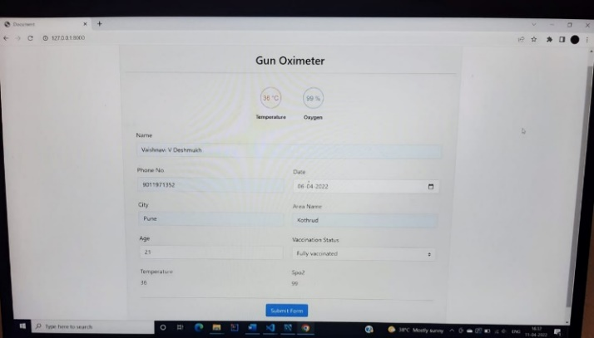

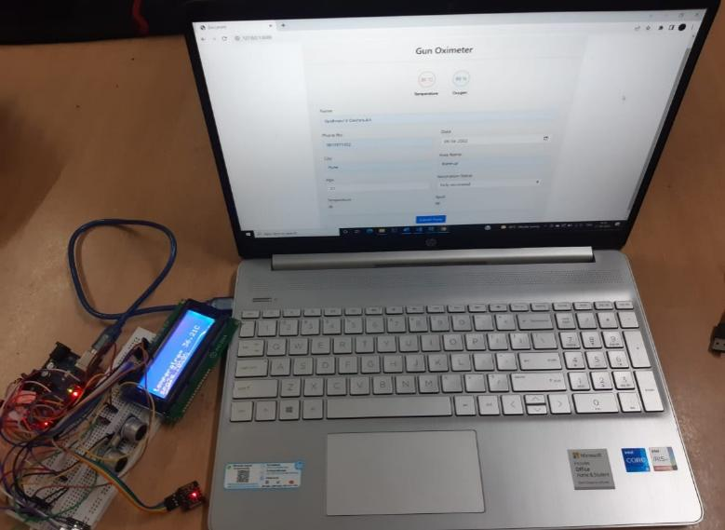

**Fig 13** Web Page and Interfacing hardware with software.

We have taken 10 readings using Gun Oximeter. About 90% of the temperature readings were accurate . The accuracy of temperature sensor of our device is quite good . The readings of the Spo2 sensor fluctuated at times. Invalid readings were captured.

Accuracy of temperature sensor is better than Spo2 sensor.

For the software part we used Django as Web framework and My SQL as Database.

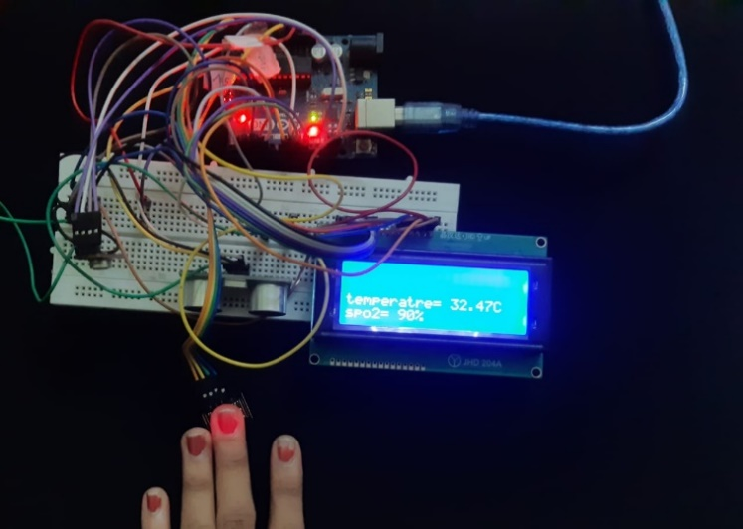

**Challenges and Problems faced**

1. The sensors not showing accurate readings at times due to fluctuations.
2. Delay in outputs. (eg MAX30102 takes 50 samples)
3. Looping the functioning of the three sensors simultaneously.
4. Power and memory management of prototype and Arduino board.

**CONCLUSION**

We have built an IOT based project . This project is divided into two main parts . Hardware and Software. We have built a device which can measure temperature and oxygen . Moreover this data will be store on MySql database. We have Arduino as our microcontroller to interface with the sensors.

For the storing part we have developed a webpage which can store the person’s readings along with the information. This data will be further analyzed for future uses.

**References**

Quast, S.; Kimberger, O. The Significance of Core Temperature—

Pathophysiology and Measurement Methods; Dräger Medical GmbH:

Lübeck, Germany, 2014.

[2] http://www.ces.fau.edu/nasa/module-2/correlation-between-

temperature-and-radiation.php

[3] Hsuan-Yu Chen, Andrew Chen, Chiachung Chen, Investigation of the

Impact of Infrared Sensors on Core Body Temperature Monitoring by

Comparing Measurement Sites, MDPI, Basel, Switzerland, May 2020

Quast, S.; Kimberger, O. The Significance of Core Temperature—

Pathophysiology and Measurement Methods; Dräger Medical GmbH:

Lübeck, Germany, 2014.

[2] http://www.ces.fau.edu/nasa/module-2/correlation-between-

temperature-and-radiation.php

[3] Hsuan-Yu Chen, Andrew Chen, Chiachung Chen, Investigation of the

Impact of Infrared Sensors on Core Body Temperature Monitoring by

Comparing Measurement Sites, MDPI, Basel, Switzerland, May 2020

1. Quast, S.; Kimberger, O. The Significance of Core Temperature— Pathophysiology and Measurement Methods; Dräger Medical GmbH: Lübeck, Germany, 2014.
2. http://www.ces.fau.edu/nasa/module-2/correlation-betweentemperature-and-radiation.php
3. Hsuan-Yu Chen, Andrew Chen, Chiachung Chen, Investigation of the Impact of Infrared Sensors on Core Body Temperature Monitoring by Comparing Measurement Sites, MDPI, Basel, Switzerland, May 2020
4. Jubran A. Pulse oximetry. *Crit Care.*2015;19 [[PMC free article](https://www.ncbi.nlm.nih.gov/pmc/articles/PMC4504215/)] [[PubMed](https://www.ncbi.nlm.nih.gov/pubmed/26179876)] [[Google Scholar](https://scholar.google.com/scholar_lookup?journal=Crit+Care&title=Pulse+oximetry&author=A.+Jubran&volume=19&publication_year=2015&)]
5. Soar J., Nolan J.P., Böttiger B.W. European Resuscitation Council guidelines for resuscitation 2015: section 3. Adult advanced life support. *Resuscitation.*2015;95:100–147. [[PubMed](https://www.ncbi.nlm.nih.gov/pubmed/26477701)] [[Google Scholar](https://scholar.google.com/scholar_lookup?journal=Resuscitation&title=European+Resuscitation+Council+guidelines+for+resuscitation+2015:+section+3.+Adult+advanced+life+support&author=J.+Soar&author=J.P.+Nolan&author=B.W.+B%C3%B6ttiger&volume=95&publication_year=2015&pages=100-147&pmid=26477701&)]
6. 3. Brennan C.E., Hong T.K.F., Wang V.J. Predictors of safe discharge for pediatric drowning patients in the emergency department. Am J Emerg Med. 2018;36:1619–1623. [PubMed] [Google Scholar]
7. Awad A.A., Stout R.G., Ghobashy M.A.M., Rezkanna H.A., Silverman D.G., Shelley K.H. Analysis of the ear pulse oximeter waveform. J Clin Monit Comput. 2006;20:175–184. [PubMed] [Google Scholar]

**APPENDIX**

**A2 Datasheets:**

1. **MAX30102 Datasheet**

**[** [**https://datasheets.maximintegrated.com/en/ds/MAX30102.pdf**](https://datasheets.maximintegrated.com/en/ds/MAX30102.pdf)**]**

1. **MLX90614**

**[https://www.sparkfun.com/datasheets/Sensors/Temperature/MLX90614_rev001.pdf]**

1. **Arduino UNO R3**

**[https://www.farnell.com/datasheets/1682209.pdf]**